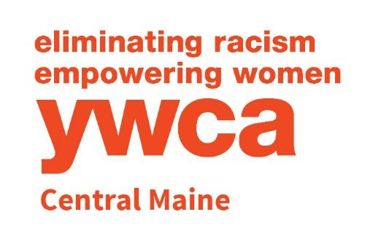

YWCA Central Maine
Early Learning Center
& Out-of-School Care
Family Handbook
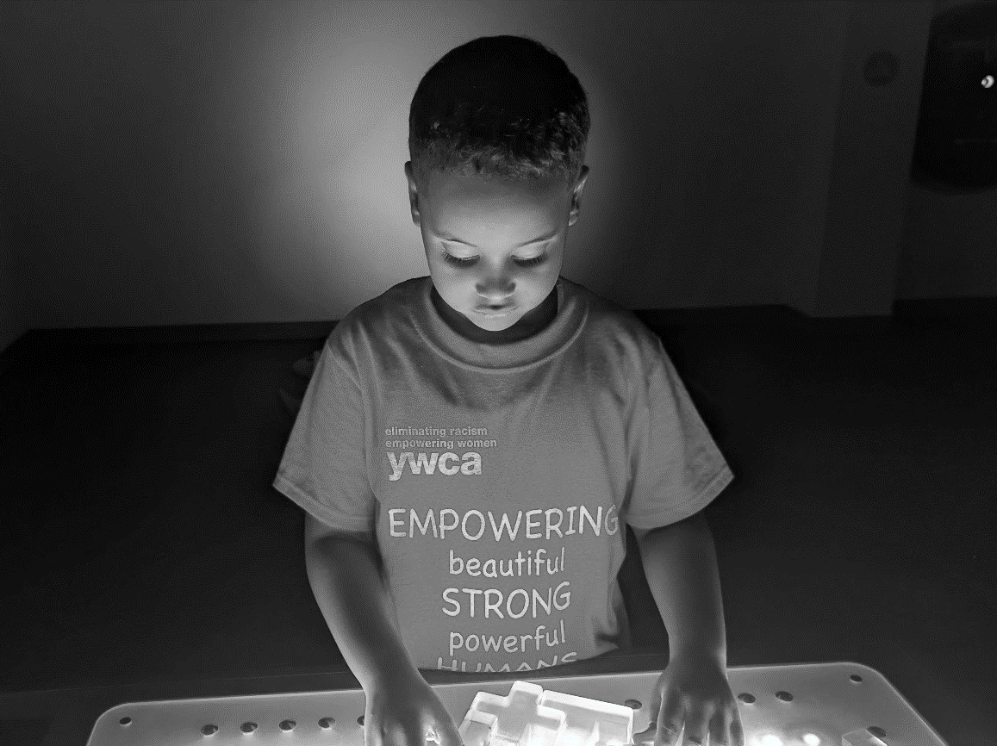
2023-2024
Please Note: All YWCA Central Maine policies and procedures are subject to change.
Table of Contents
YWCA Mission & Philosophy……………………………………………………………………………3
Program Expectations & Participant Rights………………………………………………………..….4
Ratios & Hours of Operation…………………………………………………………………………….5
Tuition & Fees…………………………………………………………………………………………….6
Curriculum & Daily Schedules…………………………………………………………………………..8
Food & Nutrition Program………………………………………………………………………………..9
Illnesses………………………………………………………………………………………………….11
Discipline…………………………………………………………………………………………………12

YWCA Mission
The mission of the YWCA is to eliminate racism and empower women while promoting peace, justice, freedom, and dignity for all.
Founded in 1878, our YWCA began as a service provider for women immigrating to Lewiston to work in the mills. The organization was originally known as the Women’s Benevolent Association and offered housing, language classes, job training, and recreation that allowed working women to thrive in their new country. The YWCA’s history inspires us to provide programming that builds community through strengthening inter-cultural relationships and valuing the needs and contributions of all of our members.
Our programming is guided by a belief in and appreciation of diversity and equitable opportunity for all people in our community. All YWCA services work toward the realization of gender and racial equity through providing accessible and culturally appropriate resources for health and wellness, recreation, education, and advocacy. The advancement of women, people of color, and economic justice in Lewiston-Auburn is integral in all that we do. From affordable early learning and out-of-school care that supports families and women in the workplace to free-of-charge therapeutic swim programs to anti-racist education and action, the YWCA strives to bring this mission to fruition in big and small ways every day.
YWCA Philosophy
YWCA Central Maine is committed to providing a healthy environment for all children while promoting self-esteem, enthusiasm for learning, and respect for oneself and others. The YWCA offers opportunities for growth through a variety of programs and activities, which may include:
- Freely expressing oneself through play, music, art, and dance;
- A love for reading;
- Nurturing the imagination;
- Gender equity;
- Learning to take care of basic personal needs;
- Listening and communication skills;
- Sharing;
- Cultural diversity;
- Promoting our local community through field trips and special visitors;
- Weekly structured swim; and
- Nutrition and physical activity.
YWCA’s Licensed Childcare Facilities
YWCA Central Maine is proud to serve the greater Lewiston/Auburn area’s families in our accessible Lewiston facility, which includes three preschool classrooms, a recently renovated gym, multiple playgrounds, kitchen, and a regulation-sized pool. Our center is licensed to serve up to 110 children at a time.

Expectations of Program Participants (Guardians and Children)
In order to foster an atmosphere supportive of our mission for all program participants, the YWCA enforces some basic rules. These rules include:
- Everyone will respect the personal space of all children and staff at the YWCA.
- Everyone will use appropriate language at all times at the YWCA (e.g. no swearing, name-calling, or references to dangerous activities, drugs, alcohol, or sexual language.)
- Everyone will be respectful of others’ property, including property that belongs to the YWCA.
Rights of Receiving Care from Child Care Facilities:
1. Children must be free from emotional, physical and/or sexual abuse, neglect and exploitation.
2. Each child has the right to freedom from harmful actions or practices that are detrimental to the child's welfare, and to practices that are potentially harmful to the child.
3. Each child has a right to an environment that meets the health and safety standards in childcare licensing rules.
4. Each child must be provided childcare services without discrimination to race, age, national origin, religion, disability, sex or family composition.
5. Children must be treated with dignity, consideration and respect in full recognition of their individuality. This includes the use of developmentally appropriate practices by the child care facility.
6. Each child has the right to the implementation of any plan of service that has been developed for that child in conjunction with community or state agencies by the child care facility.
7. Each child has the right to developmentally appropriate activities, materials, and equipment.
8. Children with disabilities have the right to reasonable modifications to child care facility policies and practices.

Rights of Parents and Legal guardians of Children receiving Care from Child Care Facilities:
1. A child's parent or legal guardian must be fully informed of items or services which are included in the rate they pay for child care services.
2. A child's parent or legal guardian has the right to be fully informed of the findings of the most recent inspection conducted by the department. The child care facility must inform children's parents or legal guardians that the licensing inspection results are public information and inspection results must be posted in a prominent place on the premises.
3. Parents or legal guardians must be notified by the child care facility within two business days of any actions taken against the child care facility by the department, including but not limited to, decisions to issue conditional licenses, refusal to renew a license, or to impose fines or other sanctions.
Teacher-to-Child Ratio
Staffing ratios in our program are regulated by the State of Maine. The YWCA is licensed to care for children 18 months through 12 years of age.
Classroom | Age Range | Ratios
Discovery Room | 18mo. – 3 years | 1 adult to 5 children
Exploration Room | 3 – 4 years | 1 adult to 10 children
Invention Room | 4 – 5 years | 1 adult to 10 children
The Future | 5 – 12 years | 1 adult to 13 children

Hours of Operation – Monday through Friday
The hours of operation are 7:00 AM to 5:30 PM.
Arrival Time
Children may not arrive prior to 7:00 AM. If you bring your child prior to 7:00 AM, you will have to wait with your child until programming begins. If your child is not planning to attend the YWCA on a scheduled day, please call the front desk at 795-4050.
Pick-Up Time
All children must be picked up by 5:30 PM. Please call the front desk at 795-4050 to notify staff if you will be unable to pick your child up on time.
Late Fees
Families who pick their children up past 5:30 PM will be charged $10.⁰⁰ for each child for each late pick up from 5:31 to 5:39 PM. Any child picked up from 5:40 PM or later will be charged $50 for each child for each late pick up. This fee will be assessed and added to your invoice to be paid with the next regular invoicing period and is subject to the same conditions as regular tuition.

Permission for Pick-Up
All people with permission to pick up a child from the YWCA, including guardians, must be listed in the child’s enrollment paperwork. YWCA staff are instructed to check photo identification for any adults with whom they are unfamiliar. Please notify your child’s teacher and provide written permission in the event that someone who is not already listed will be picking up your child.
School Vacation and Teacher Workshop Days
YWCA childcare is open for the same hours during local public school vacation and teacher workshop days (7:00 AM – 5:30 PM), unless otherwise noted on our calendar. Please note that additional tuition for full day care is required.
Inclement Weather
The YWCA does not automatically close when local schools are canceled due to inclement weather. If the YWCA decides to open late or close early due to inclement weather, an emergency situation, or another reason, the notification will be broadcast on local television stations and social media. If school is closed due to inclement weather or other unplanned reasons, YWCA childcare may be open from 7:00 AM to 5:30 PM. Please note that additional tuition for full day care is required.
Transportation
Children will not be transported to or from the YWCA without signed parental permission, except in the case of an emergency.
Emergency Transportation Locations (e.g.: flooding, fire) are:
Lower rear parking lot away from building, YWCA Central Maine
Lewiston High School, 156 East Ave, Lewiston, Me 04240, (207) 795-4190
Robert V. Connors Elementary School, 400 Bartlett St. Lewiston (207) 795-4130
Tuition and Fees
Children in all YWCA Central Maine Early Learning Center and Out-of-School Programs are required to have an active YWCA Community Access Pass. This can be held as an individual pass or as part of a family pass. The current YWCA Community Access Pass fee is $45.⁰⁰ and is valid for one year. Each child’s Community Access Pass must be renewed on an annual basis.
A $25.⁰⁰ registration fee is required when a child is signed up for a new program (e.g. summer camp, enrollment in preschool, or after school care). This means that each new school year (in the fall for those continuing care from the summer/prior school year), guardians will be charged a $25.⁰⁰ registration fee for their child’s entrance into care for the upcoming school year.
School Year
Children who attend out-of-school care during the school year must pay tuition weekly, regardless of whether school is in session, in order to reserve their spot in programming. Tuition for full day care during school vacation weeks will be calculated in addition to the regular cost for each family’s school year care.

Vacation Care
Out-of-school care during school vacations and other school days off is available to both families who currently access YWCA out-of-school programs and other families in the community; therefore, advanced registration and payment is required.
Approximately two weeks prior to a planned school vacation, teacher workshop day, or holiday, a sign-up sheet will be placed at the sign-in/sign-out table.
**Families who wish to reserve care for their child(ren) on those weeks/days are required to sign them up in advance so the YWCA can ensure the required number staff are available. Families who have signed their children up for care will be billed for those days, regardless of whether their child attends. Families who do not sign up for care in advance will not be allowed to drop off their children on those days. This is due to capacity and staffing ratios mandated by the state.**
Full day care for school aged children is available for $45.⁰⁰ per day or $160.⁰⁰ per vacation week. For families already enrolled in YWCA care, these amounts, in combination with regular weekly tuition, will never exceed $160.⁰⁰ total per week. Regular weekly tuition for children who attend before and/or after school care is due, regardless of whether children attend on vacations or holidays.
Summer Camp
Summer camp is a separate program from typical care during the school year. Camp requires a separate registration and enrollment process for school-aged children. The registration process, including scholarship applications, is available in the spring.
Voluntarily Withdrawing Your Child from the Program
In order to withdraw your child from care at the YWCA, two weeks’ prior written notice must be submitted in writing to: Director of Childcare Services
YWCA Central Maine
130 East Ave.
Lewiston, ME 04240
Or emailed to: cparritt@ywcamaine.org
Guardians will be billed their contracted rate (full-time or part-time) for the two weeks following the receipt of notice to withdraw, regardless of the child’s attendance during that two-week period. Please note that notices sent by mail will not be processed until received at our office; and notices received during the weekend will not be processed until the next business day.

Curriculum & Daily Schedules
Routines are critical to classroom management and establishing transitions. Below is a table to determine approximate routines based on classrooms:
Time | Discovery Room | Exploration  Room | Invention  Room | The Future (School Aged)
7AM | Drop Off/ Quiet Centers | Drop Off/ Quiet Centers | Drop Off/ Quiet Centers | Drop Off/ Bus Pick-Ups
8:30 | Breakfast | Breakfast | Breakfast | Attendees @ school
9:00 | Circle to Centers | Circle to Centers | Circle to Centers
10:00 | Outside/Gross Motor Activities | Outside/Gross Motor Activities | Outside/Gross Motor Activities
11:00 | Handwashing/ Lunch | Handwashing/ Lunch | Handwashing/ Lunch
12:00 PM | Rest Time | Rest Time | Rest Time | Half Day Arrivals
2:30 | Snack | Snack | Snack | Drop Off/ Snack
3:00 | Outside | Inside Centers | Inside Centers | Clubs/ Activities
4:00 | Inside Centers | Outside | Outside
5:00 | Clean Up/  Pick Up | Clean Up/  Pick Up | Clean Up/  Pick Up | Clean Up/ Pick Up
The activities listed above can include, but are not limited to, sports games, art, costuming, swimming, STEM projects, library time, coloring, or gardening. We also make reasonable accommodations for various activities.
Swim times will be documented in our ProCare App.
English Language Learners Policy:
Here at the YWCA Early Learning Center and Out-of-School Programs, we accept learners from all backgrounds. The primary language we communicate in is English. If you communicate more comfortably in another language, please let us know. We will make every effort to make our materials and communications accessible for you in your preferred language. We will also incorporate your child’s language and culture into our visuals and communications as much as possible.
ProCare App
We currently employ an administrative tool called ProCare. This app allows parents and guardians to sign their children in and out using personalized codes, as well as view information regarding current lessons or activities within the classroom. To use this tool, simply download the app from the Google Playstore or Apple App Store. We will need a functioning email address on file to connect guardians to their child’s profile.
ProCare has an in-app messaging system that staff will utilize to keep guardians informed of schedule changes, swim reminders, paperwork deadlines, artwork, and so much more. Guardians can also use this messaging system to inform staff of upcoming appointments, illnesses, pick-ups, or any other questions or concerns.
Aquatics
As water safety is an essential life skill, aquatics are a fundamental part of programming at the YWCA. School-aged students attending out-of-school care participate in free swim one time per week for one hour. Please confirm the time of school-age swim with the Director of Childcare Services. This time is subject to change during the school year; however, any changes will be communicated to guardians in advance. Please pack a bathing suit, towel, and water shoes for your child on their scheduled swim day. The YWCA aquatics program provides a certified lifeguard who is on duty whenever the children are in the pool area.
Rest Time
Per Maine State Child Care Licensing Rules, preschool children are required to participate in rest time each day. The YWCA will provide children with individual mats. Please send a blanket and/or pillow for your child to use during rest time. It is expected that blankets and pillows be brought home to be washed on Friday and returned for use on Monday morning.
Food & Nutrition Program
The YWCA participates in the USDA Child and Adult Care Food Program (CACFP). The CACFP is a federal program that provides reimbursements for nutritious meals and snacks to eligible children and adults who are enrolled for care at participating child care centers, day care homes, and adult day care centers. All children who attend Early Learning Center or Out-of-School programs at the YWCA will receive the same nutritious meals and snacks, regardless of income.
Breakfast
Breakfast is not served as part of the school-aged before school program; however, the YWCA provides breakfast for children in preschool and all-day out-of-school care.
Lunch
Lunch, in accordance with CACFP guidelines, are provided to all children and youth attending full-day care, which includes preschool students and school-aged students on teacher workshop days and vacation days.
Snacks
After school snacks are provided to all children and youth each afternoon. For students attending after school, snacks and drinks are served when students arrive at the YWCA after school.
Outside Food
Due to the nature of our food program funding and varying allergies, there is no outside food or beverage allowed in the facility. Treats for parties/celebrations must be store bought and in the original packaging. Please inform the Director of Childcare Services if you intend to bring treats for your child to share. Healthy choices are appreciated, and a healthy treat suggestion list is available upon request.
As the YWCA focuses on providing healthy, nutritious snacks, water or low-fat milk will be served and sugary beverages are not permitted under any circumstances.

Food & Nutrition Program – USDA Non-Discrimination Statement
In accordance with Federal civil rights law and U.S. Department of Agriculture (USDA) civil rights regulations and policies, the USDA, its Agencies, offices, and employees, and institutions participating in or administering USDA programs are prohibited from discriminating based on race, color, national origin, sex, disability, age, or reprisal or retaliation for prior civil rights activity in any program or activity conducted or funded by USDA.
Persons with disabilities who require alternative means of communication for program information (e.g. Braille, large print, audiotape, American Sign Language, etc.), should contact the Agency (State or local) where they applied for benefits. Individuals who are deaf, hard of hearing or have speech disabilities may contact USDA through the Federal Relay Service at (800) 877-8339. Additionally, program information may be made available in languages other than English.
To file a program complaint of discrimination, complete the USDA Program Discrimination Complaint Form, (AD-3027) found online at: How to File a Complaint, and at any USDA office, or write a letter addressed to USDA and provide in the letter all of the information requested in the form. To request a copy of the complaint form, call (866) 632-9992. Submit your completed form or letter to USDA by:
- Mail: U.S. Department of Agriculture
Office of the Assistant Secretary for Civil Rights
1400 Independence Avenue, SW
Washington, D.C. 20250-9410;
- Fax: (202) 690-7442; or
- Email: program.intake@usda.gov
This institution is an equal opportunity provider.
Food & Nutrition Program – State of Maine Non-Discrimination Statement
The Maine Human Rights Act prohibits discrimination because of race, color, sex, sexual orientation, age, physical or mental disability, genetic information, religion, ancestry or national origin.
Complaints of discrimination must be filed at the office of the Maine Human Rights Commission, 51 State House Station, Augusta, Maine 04333-0051. If you wish to file a discrimination complaint electronically, visit the Human Rights Commission website at https://www.maine.gov/mhrc/file/instructions and complete an intake questionnaire. Maine is an equal opportunity provider and employer.

Illnesses
Please do not send your child to the YWCA if they are ill, vomiting, or have a fever. The YWCA does not have a nurse on staff, and the health and safety of other children and adults in the building is of utmost importance. Children attending childcare at the YWCA must be well enough to participate in all activities, including outdoor play and swim. Below is a list of symptoms that may prevent your children from participating in YWCA programs:
- Fever (**must be gone for 24 hours without medication prior to returning to care**)
- Unexplained rash
- Persistent cough
- Profuse discharge of discolored mucus from nose, eyes, and/or ears
- Diarrhea
- Vomiting
- Sore throat
- Head lice
- Other signs of contagious illness
If a child appears listless, feverish, or ill while attending the YWCA, guardians will be called and asked to pick up their child. If a guardian cannot be reached, an emergency contact will be called. Once a child is sent home sick, they may not return to the YWCA until they are free from the symptoms or concern. A doctor’s note may be requested.
Medication
For YWCA staff to administer prescription or over-the-counter medication to a child, a signed permission form must be on file for each medication. Medications kept at the YWCA must be in the original container with dosing instructions. Medications will be kept locked up and administered by authorized staff only.
Clothing
Please send your child to the YWCA with adequate clothing for the weather. Dressing them in, or providing them with, layers is recommended. The children spend a significant amount of time outside releasing energy and getting exercise. It is highly recommended that you label all of your child’s personal belongings with their name, as the YWCA will not be held responsible for any lost or stolen items. Children should have shoes that will stay on their feet during outdoor play. Open-toed or loose shoes are not recommended. Providing an extra set of clothing is also strongly encouraged for younger children.
Sunscreen
Children may be asked to apply sunscreen on themselves multiple times per day on sunny days. Please send your child with a labeled bottle of sunscreen to protect them from the sun’s harmful rays during outdoor play.
Physical Activity
Children attending the YWCA will participate in many physical games and activities each day. They will have the opportunity to swim at least once per week and children will go outside daily, weather-permitting. On rainy or freezing days, gross motor activities will take place in the gym or classroom.

Field Trips
Occasionally, children may go on trips to playgrounds, museums, beaches, or other engaging and educational places. Guardians will be notified in advance and must sign a permission slip in order for their child to attend. The handling of medical conditions during these trips is governed by State law and requires forms and policies that will be explained by your child’s teacher and/or the Director of Childcare Services. There may be additional costs associated with field trips, such as admission or transportation fees.
Personal Equipment and Toys (Including Electronics)
To prevent loss of and damage to personal toys, trading cards, and more, please do not send any of these items with your child. The YWCA will not be responsible for any lost or stolen items. Children are not allowed to bring video games or electronic devices of any kind to the YWCA. This includes, but is not limited to, tablets, Game Boys, PSPs, Nintendo DS, MP3 players, and cell phones.
Distance Learning
Due to school closures and other family needs, some children are required to use laptops to access distance learning, counseling, special education services, and more. Arrangements to store and use laptops during care should be made through the Director of Childcare Services. Laptops, tablets, etc. will not be used in the gym.
Screen Time
It is very important that the children spend their time at the YWCA developing social skills, practicing problem solving skills, and engaging in physical activity. As such, any computer time will be related to academics (e.g. STEM, distance learning), and TV/movie time will be limited to special occasions or rainy days.
Visitation and Guardian Questions
At the YWCA, we encourage visitation and welcome you to visit your child at any time. Concerns about how conflicts are handled, or questions about routines and procedures, may be addressed with the Director of Childcare Service or the lead staff member on site at pickup. In addition, you may contact the Director of Child Care Services to discuss YWCA policies, licensing questions, and rules associated with the early learning programs.
Discipline and Problem Behaviors
YWCA Central Maine’s Early Learning Center and Out-of-School Programs concentrate on rewarding and reinforcing children’s creative work and positive behavior. The more opportunities a child has for building confidence and skills for self-expression in an atmosphere of approval, the better and more positive the experience will be for all children.
Guiding Principles for Discipline
There are three principles that guide consequences in the programs at the YWCA with regard to negative behaviors. These principles are:
Natural Consequences: Natural consequences are those things that happen in response to your child's behavior without guardian/teacher involvement. These are imposed by nature, society, or another person. An example of a natural consequence would be a child missing out on the beginning of an activity because he or she was not listening to the instructions.
Proportion: The concept of proportion means that the severity of the consequence given for a behavior should match (be proportionate to) the degree of seriousness of the negative behavior. For example, a minor or unintentional shove will result in a less severe consequence (e.g. reminder about personal space) than hitting with the intent to injure (e.g. a written incident report and/or time out).
Progressive Discipline: The nature of consequences will progress if disruptive behavior worsens or is not modified by typical strategies. If a child is unable to follow the YWCA’s basic rules, clear and firm reminders of expectations will be communicated to remind the child and to help redirect potentially disruptive behavior toward a more constructive solution. Simple reminders are used first, with suggestions of how to change and move toward the positive. More restrictive consequences, such as taking time away from an activity, are employed when simple reminders are not effective. General reminders of all rules are conveyed periodically within the entire program. If your child is having difficulty following the YWCA rules more than occasionally, a staff member will likely enlist your help in reinforcing these concepts at home to prevent further harm, disruption, and/or termination.
Property Damage
If a child damages property at the YWCA or in the community while in the care of the YWCA, that child’s guardians will be held financially responsible for the damage(s). If damage occurs in a community facility, their rules for covering damage(s) may also apply.
Bullying
Bullying is detrimental to children and interferes with the mission of the YWCA. Children who engage in acts of bullying are subject to the consequences listed in this handbook, up to and including suspension or termination of care.
The Centers for Disease Control and Department of Education define bullying as:
- Unwanted aggressive behavior
- Observed or perceived power imbalance
- Repetition or high likelihood of repetition of bullying behaviors
The YWCA further considers “bullying” to include the following (list is not exhaustive):
- Written, verbal, electronic, or physical expressions, acts, or gestures
- Any act that physically harms a student or their property
- Any act that creates an intimidating or hostile environment for a child
- Any act that interferes with another child’s ability to participate in activities
- Any act that seeks to harm, intimidate, or coerce someone perceived as vulnerable

Incident Reports and Suspensions
Children who do not adhere to behavioral expectations may receive written incident reports describing their interfering behavior(s). These reports may be written to document incidences of aggression, swearing, disrespect, property destruction, bullying, harassment, and more. Incident reports serve as documentation to monitor problem behaviors and as a written point of contact with guardians should the need for further action arise.
Children are sometimes suspended from the YWCA for unsafe and unkind behaviors. Suspensions are handed down from the Director of Childcare Services (or the substitute program lead) only. Guardians and children will typically receive a warning before a suspension takes place, but this cannot be guaranteed as the procedure necessarily corresponds to the nature of the behavior. Suspensions may range from one day to one week or longer.
Suspension and/or Involuntary Termination
Occasionally, a child will experience difficulty in acclimating to the center’s environment or abiding by the rules of behavior established by the center and/or required by the state.
If the rules and policies set forth are not followed, YWCA Central Maine reserves the right to suspend or terminate the contract agreement at any time. In such an event, guardians will be billed through the end of the week in which such termination occurs or billed for the days of suspension. Possible reasons for suspension and/or termination from the program include, but are not limited to:
- Failure to comply with policies set forth in the guardian’s handbook
- A child’s destructive or hurtful behaviors that persists even with guardian cooperation in stopping the behavior
- Inability to meet the child’s needs without additional staff
- Non-payment of care or late fees and/or recurring late payments of fees.
To avoid termination or suspension, teachers and staff will meet with families to discuss the situation and available resources at the YWCA. The Director of Childcare Services (or the substitute program lead) may also recommend additional supportive services and/or make referral(s) for services when deemed necessary, which may include consultation, educator training, evaluation, and more. If a child is suspended or terminated after exhausting all opportunities for sustaining enrollment, the program will provide the guardian with the specific conditions under which the child may return, if any.

